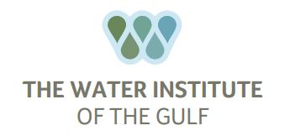

Nick Howes

**Experience Profile**Nick Howes, Research Scientist, brings years of experience in applied geoscience and machine learning to The Water Institute.

During his eight years as an applied scientist at Shell, he worked on a cross-disciplinary team focused on subsurface characterization, was appointed a subject-matter expert in shallow marine and fluvial reservoir characterization and developed a data framework to store geologic data and automate feature engineering for machine learning. Prior to joining The Water Institute, Howes was a Senior Technical Consultant with MathWorks, a developer of mathematical software where he led projects in areas of artificial intelligence, data/experimentation management including big data, and application development.

Howes’ geoscience research expertise examines how landscapes respond to changes such as storms or sea level rise and how these changes impact people.

**Professional Experience**

The Water Institute of the Gulf 2021-Present

* *Research Scientist L3*

MathWorks Inc. 2017-2021

* *Senior Technical Consultant*

Shell International Exploration and Production B.V. 2009-2017

* *Applied Scientist*

Boston University 2007-2009

* *Research Assistant - Teaching Fellow*

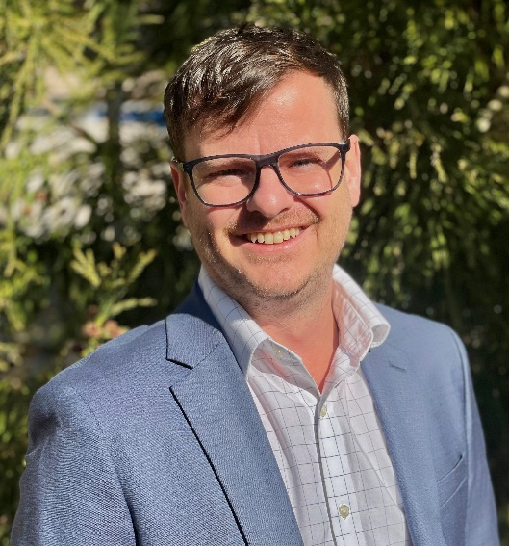

**Company Role**

Research Scientist

**Areas of Expertise**

* Geosciences
* Stratigraphy
* Geomorphology
* Machine Learning
* Software Development
* Geospatial Frameworks

**Education**

* M.A.- Earth Sciences, Boston University 2009
* B.A.- Earth Sciences, Boston University 2007

**Professional Membership**

* American Geophysical Union

**Selected Projects**

**Lower Mississippi River Management Program**(2021-ongoing)

Identification of future scenarios for sediment and water management that provide holistic value across coastal protection, navigation, ecosystem restoration, including associated costs and benefits. Technical implementation uses system dynamics and surrogate models integrated within a framework for robust decision-making to identify management scenarios.

**SmartPort** (2021-ongoing)

Crowd-sourced hydrographic data and modeling to inform a near-real time shoaling forecasting tool at the Port of New Orleansand other ports along the Mississippi River.

**Selected Publications**

1. Jobe, Z.R., **Howes, N.C**., Martin J., Meyer R., Coutts D., Hou P., Stright L., and Laugier F. 2021. Sedimentary Graphic Logs: A Template for Description and a Toolkit for Digitalization. The Sedimentary Record. <https://doi.org/10.2110/sedred.2021.3.3>
2. van der Vegt, H., Storms, J.E.A, Walstra, D.J.R., Nordahl, K., **Howes, N.C.**, Martinius, A.W. 2020. Grain size fractionation by process-driven sorting in sandy to muddy deltas. The Depositional Record. <https://doi.org/10.1002/dep2.85>
3. Jobe, Z.R., **Howes, N.C.**, Straub, K.M., Cai, D., Deng H., Laugier, F.J., Pettinga, L.A., Shumaker, L.E. 2020. Comparing aggradation, superelevation, and avulsion frequency of submarine and fluvial channels. Frontiers in Earth Science. <https://doi.org/10.3389/feart.2020.00053>
4. Kirschner, D., **Howes, N.C.**, Daly, C., Mukherjee, J Li, J. 2019. Detecting P-and S-wave arrivals with a recurrent neural network. Society of Exploration Geophysicists Conference Proceedings. <https://doi.org/10.1190/segam2019-3215081.1>
5. Martin, J., Fernandes, A. M., Pickering, J., **Howes, N.C.**, Mann, S., Neil, K. M. C. 2018. The stratigraphically preserved signature of persistent backwater dynamics in a large paleodelta system: the Mungaroo Formation, northwest shelf, Australia. J. Sedimentary Research. <https://doi.org/10.2110/jsr.2018.38>
6. Pettinga, L., Jobe, Z.R., Shumaker, L., **Howes, N.C.** 2018. Morphometric scaling relationships in submarine channel-lobe systems. Geology <https://doi.org/10.1130/G45142.1>
7. Jobe, Z.R., **Howes, N.C.**, Auchter, N. 2016. Comparing submarine and fluvial channel kinematics: Implications for stratigraphic architecture. Geology. <https://doi.org/10.1130/G38158.1>
8. van der Vegt, H., Storms, J.E.A, Walstra, D.J.R., **Howes, N.C**. 2016. Can bed load transport drive varying depositional behavior in river delta environments? Sedimentary Geology. <https://doi.org/10.1016/j.sedgeo.2016.08.009>
9. Jobe, Z.R., Sylvester Z., Parker A.O., **Howes N.C.**, H. Slowey, N., Pirmez C. 2015. Rapid adjustment of submarine channel architecture to changes in sediment supply. J. Sedimentary Research. <https://doi.org/10.2110/jsr.2015.30>
10. **Howes N.C.**, FitzGerald D.M., Hughes, Z.J., Georgiou I.Y., Kulp M.A., Miner M.D., Smith J.M., Barras J.A. 2010. Hurricane-induced failure of low salinity wetlands. Proceedings of the National Academy of Sciences. <https://doi.org/10.1073/pnas.0914582107>