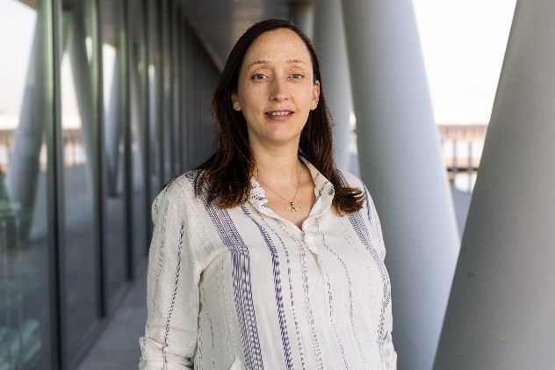
KATya WOWK, PH.D.
COMPANY ROLE
Senior Social Scientist
PROJECT ROLE / FOCUS AREAS
Community resilience

Knowledge co-production

Community engagement

Natural infrastructure

Disaster mitigation

EDUCATION
PhD, Ocean & Coastal Policy, University of Delaware, 2011

MPA, Environmental Science and Policy, Columbia University, 2005

B.S., Ecology, Central Connecticut State University, 2004

PROFESSIONAL MEMBERSHIP
Editorial Board Springer Nature Humanities & Social Sciences
Global Ocean Forum Policy Advisory Board
Coastal Bend Regional Resilience Partnership
Coastal Bend Community Organizations Active in Disaster

Senior Social Scientist
Katya Wowk is an expert in using inter- and transdisciplinary approaches to strengthen community resilience to disasters and climate change. With most of her work focused in the Gulf of Mexico and Texas, she focuses on partnering with communities on the frontlines of environmental and societal change to understand resilience at the hyper-local level, as well as the assets, barriers and tradeoffs that are inherent or need to be addressed to advance local visions and goals.
Previously, she served as Chair for Community Resilience and Senior Research Scientist at the Harte Research Institute for Gulf of Mexico Studies (HRI), Texas A&M University-Corpus Christi (TAMUCC), where she led a diverse team focused on co-producing the science needed to build resilience at the local level, In 2019 she also cofounded the Coastal Bend Regional Resilience Partnership in the aftermath of Hurricane Harvey, which is a formal association with the Coastal Bend Council of Governments focused on building local capacity to mitigate disaster risk. Katya also was Director of the Texas OneGulf RESTORE Center of Excellence, where she and the team co-produced science with five Texas state agencies.
Prior to positions with HRI, Katya served as Senior Social Scientist to the Chief Economist for the U.S. National Oceanic and Atmospheric Administration (NOAA), Senior Policy Official to the Assistant Secretary of Commerce for Conservation and Management, and Program Coordination Officer to the Under Secretary of Commerce for Oceans and Atmosphere (NOAA Administrator).Katya holds a Ph.D. in International Coastal and Ocean Policy from the University of Delaware and an M.P.A. in Environmental Science and Policy from Columbia University.
PROFESSIONAL EXPERIENCE
2023–Present: Senior Social Scientist, The Water Institute
2022–2023: Chair for Community Resilience, HRI, TAMUCC
2019–2023: Director of Texas OneGulf RESTORE Center of Excellence
2015–2022: Senior Research Scientist, HRI, TAMUCC
2014–2015: Senior Social Scientist (Consultant), Office of the Chief Economist, National Oceanic & Atmospheric Administration (NOAA)
2013–2014: Senior Policy Lead (Contractor), Office of the Assistant Secretary of Commerce for Conservation and Management, NOAA Headquarters
2012–2013: Program Coordination Officer to NOAA Administrator (Contractor), National Ocean Service (NOS), NOAA Headquarters
2010–2012: Deputy Director, NOAA Programs, Earth Resources Technology, Inc.
2008–2010: Policy Specialist (Contractor), NOAA/National Marine Protected Areas (MPA) Center

SELECTED PROJECTS
Improving Health Equity and Health Data Systems National Academies of Sciences Gulf Research Program & Robert Wood Johnson Foundation (Ongoing). Lead transdisciplinary project to understand social determinants of health, climate change and health equity in Nueces County, TX, to better inform public and private health data systems and plans.
Planning for Economic Resilience and Hazards in Rural Communities Economic Development Administration (Ongoing). Leading community-based project to understand and advance economic resilience in the face of climate hazards in two small, rural Texas towns and counties, including through co-developing local economic resilience action plans.
Sea Level Rise Planning National Oceanic and Atmospheric Administration (Ongoing). Leading co-production and coordination of the Management Transition Advisory Group for the Effects of Sea Level Rise 2021 project on Coastal Resilience: Living with Sea Level Rise in the Texas Coastal Bend, which focuses on improved modeling to assess the potential of natural and nature-based features to mitigate risk.
Geospatial Economic Resilient Development (GeoRED) Economic Development Administration and Texas Commission on Environmental Quality (2020-2023). Led interdisciplinary team to create the first geospatial platform for the Texas Coastal Bend, including seven counties and four tools tailored by and for local communities. The tools on Hazards Planning, Social Vulnerability, Economic Development and Environmental Resilience assist communities in co-developing smart growth practices with local data.
Local Data for Community Development Block Grant Mitigation Funds Planning Texas General Land Office via Coastal Bend Council of Governments (2022). Led team to co-develop a method of distribution using data prioritized by local officials in nine counties for the allocation of $179,547,000 in CDBG-MIT funds following Hurricane Harvey and additional flood disasters. The planning resulted in use of key data sets in Mapping Flood Hazards and Vulnerability in the Coastal Bend, which led to more meaningful discussions on mitigation priorities.
Resilience Training for Local Experts Earl C. Sams Foundation (2020-2021). Led development and implementation of a training program for local officials and stakeholders in the Coastal Bend. Participants networked with experts around Texas and the nation to discuss methods for building community resilience and capacity, and worked with local partners to create data-informed funding and action strategies.
Integrating Socioeconomics in the Community Resilience Index Gulf of Mexico Alliance (2018-2020). Led analysis of potential integration of Community Resilience Index (CRI) exercises with Community Rating System (CRS) actions, including how CRI communities could be better incentivized and supporting to pursue CRS actions.
SELECTED PUBLICATIONS
- Backer, L., A. Lavery, H. Solo-Gabriele, A. Schnall, V. Robers, M. Vigar, M. Gleason, S. Kieszak, J. Estenik, A. Reich, C. Court, K. Wowk, W. Blair Stephan, B. Kirkpatrick, V. Trainer, R. Stumpf, K. Coffey, R. Koeneke and R. Botta. 2023. Monitoring and measuring human health and well-being. In: Oceans and Human Health: Opportunities and Impacts, 2nd Ed., L. Fleming et al. Elsevier.
- Wowk, K., M. Adams & E. Martinez. 2023.Translating the Complexity of Disaster Resilience with Local Leaders. Frontiers in Communication. Vol. 8.
- Sandifer P., A. Ferguson, M. Finucane, M. Partyka, H. Solo-Gabriele, A. Hayward Walker, K. Wowk, R. Caffey, and D. Yoskowitz. 2021. Human Health and Socioeconomic Effects of the Deepwater Horizon Oil Spill in the Gulf of Mexico. Oceanography, Vol. 34:1.
- Wowk, K., L. McKinney, F. Muller-Karger, R. Moll, S. Avery, E. Escobar-Briones, D. Yoskowitz and R. McLaughlin. 2017. Evolving academic culture to meet societal needs. Palgrave Comms. 3:35.
- Sutton-Grier, A., H. Bamford and K. Wowk. 2015. Future of Our Coasts: The Potential for Natural and Hybrid Infrastructure to Enhance the Resilience of Our Coastal Communities, Economies and Ecosystems. Enviro. Sci. and Policy. 51:137-148.

