Real-Time Forecasting
  - Providing Advanced Flood warning for Inland
and Coastal Communities
June 12, 2017

A severe weather system descended upon southeast Louisiana in August 2016, bringing more than 30 inches of rain to some areas within a matter of days. The resulting flood, which far exceeded the 100-year flood plain delineated by the Federal Emergency Management Agency in many areas, caught municipalities and residents by surprise. The flash nature of the flooding left local governments and residents with little time to prepare themselves or their property for the flooding that would occur.
Over the past few years, a series of hurricanes made landfall along the Louisiana coast including hurricanes Katrina, Rita, Gustav, Ike, and Isaac. Along with bringing storm surge damage to coastal communities, these storms brought heavy rainfall into inland watersheds creating flash flood and backwater flooding disasters.

Real-Time Forecasting tools that use weather forecasts and hydrological or coastal numerical models are powerful tools that can provide the opportunity to minimize or help mitigate severe weather and flood-related disasters and save lives by providing advanced warning of flooding events.

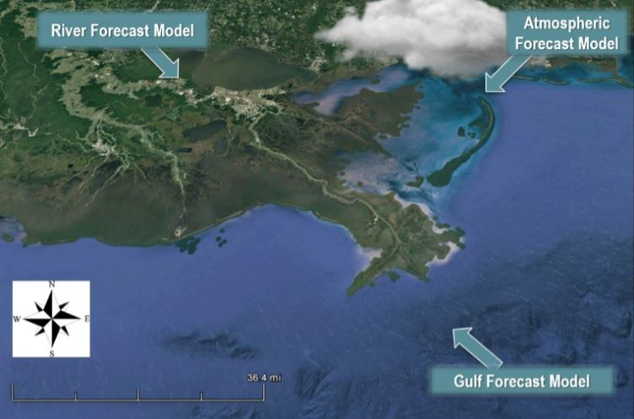
The Water Institute of the Gulf (Institute) and Deltares have developed a forecasting and information system for the Barataria Bay and Breton Sound basins in the Mississippi River delta. The system provides a seven-day forecast of the hydrological conditions (e.g., water level, salinity, and temperature) and how it will impact the basins under expected atmospheric and coastal conditions (See Figure 1)

This tool gives advance guidance to decision makers operating sediment and freshwater diversions along the Mississippi River by forecasting how and when certain conditions may be met for optimal benefit. Example forecast maps are shown in Figure 2.

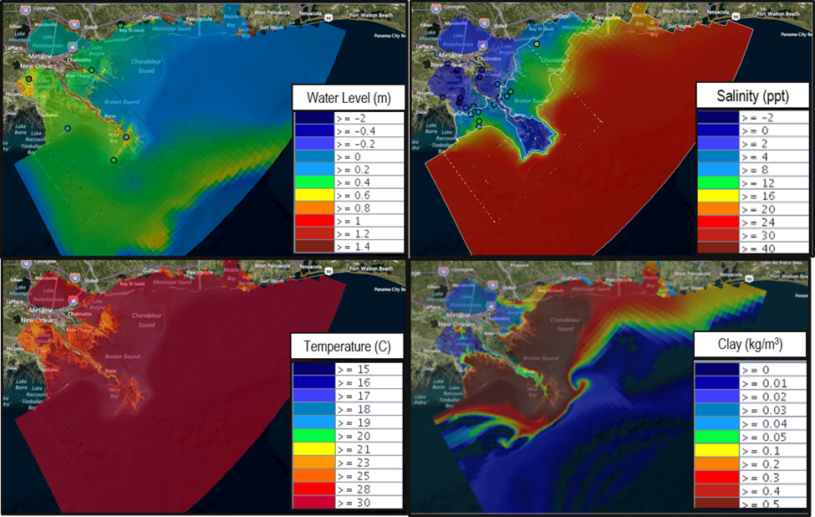
This tool builds on Delft-FEWS (Flood Early Warning System), a software developed by Deltares. Delft-FEWS is used as a platform to import environmental data from several sources and uses this information to drive the numerical model. The power of this tool is the ability to combine real-time data, information, and weather forecasts from multiple sources such as the National Oceanic and Atmospheric Administration, U.S. Geological Survey, state of Louisiana, and U.S. Army Corps of Engineers.
Figure 1: Coastal Real-Time Forecasting tool developed by the Institute and Deltares and schematic representation of the main data and external forecasts driving the system.

A similar tool can be applied to local inland watersheds to forecast flood extent and flood elevations for a short-time future (3-5 days) and on a detailed – down to the street level – resolution. (See Figure 3)

In areas like south Louisiana, inland watersheds are often directly connected to the coastal zone. In these cases, flooding occurs directly from rainfall events or tides/waves/surge or all the above. This complex interaction underscores the importance of developing coastal and inland numerical models that can be seamlessly and effectively integrated. The Institute is uniquely situated to bring these inland and coastal factors together for a more complete picture of potential flooding since the Institute is heavily involved in developing numerical models for the entire Louisiana coast. Furthermore, the Institute has been designated a Cooperative Technical Partner (CTP) by FEMA and works closely with the Department of Transportation and Development in that capacity. Our previous work and state-of-the-art capabilities, coupled with our strong partnership with Deltares, puts the Institute in the ideal position to coordinate the development of the powerful Real-Time Forecasting system the State of Louisiana needs.
Figure 2: Example of the coastal Real-Time Forecasting tool output: water level (top left), salinity (top right), temperature (bottom left), and clay concentration (bottom right).

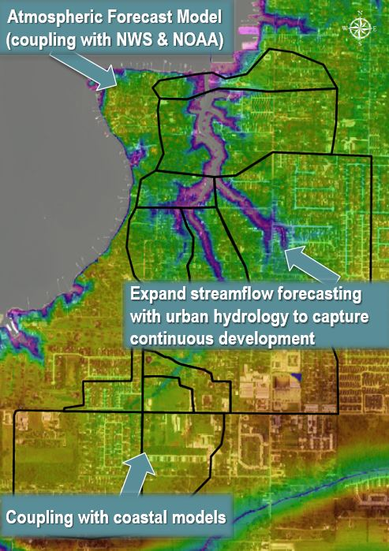
Designed to give emergency responders, governments, and residents more time for better preparations, this Real-Time Forecasting tool can provide a flash flood forecasting and warning system based on the specific topography and hydrology of the area in question. By incorporating land elevations, land use, and drainage information into the modeling, the Real-Time Forecasting tool can provide estimates of flood depths, potential road closures, and flood duration for specific locations.

Since water does not respect city or parish borders, the model would be best utilized on a watershed (or larger) basis. For example, if the Real-Time Forecasting system was applied to the Amite River basin, a high-resolution numerical model could be developed to simulate the flow of the Amite River. Then, this numerical model would be plugged into the Real-Time Forecasting platform DelftFEWS. This Real-Time Forecasting platform would then be linked to regional and national forecasting systems to include information like rainfall, soil moisture, and wind. Such a tool will be able to predict potential flood events days in advance.
Figure 3: Schematic representation of the Real-Time Forecasting tool components for an inland watershed. Example applied for the Calcasieu Parish.

By turning these results into graphical images that could include flood inundation maps or animations that show flooding potential, the forecast results would help identify neighborhoods, major roads, and critical infrastructure that might be subject to flooding. (See Figure 4)
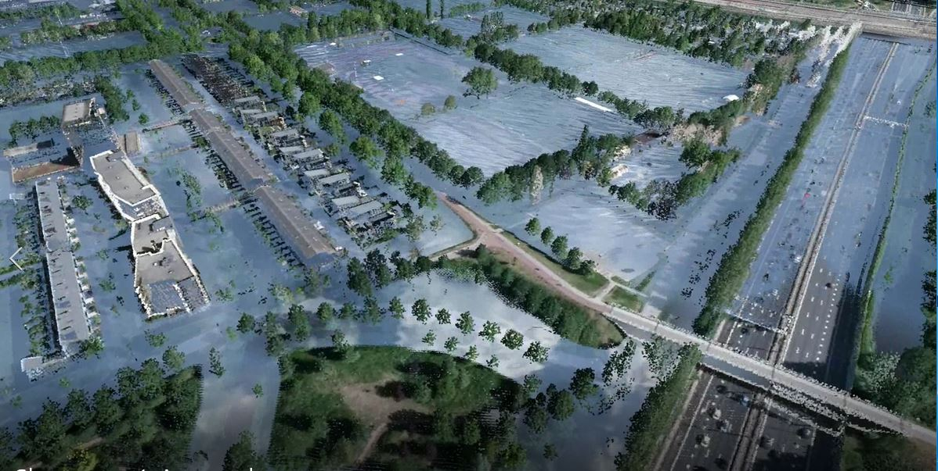
Local governments would be trained to learn how to use the system, how to make the forecast model outputs more visually accessible, and how to get the most of the information provided.

To help with the use and adoption of the Real-Time Forecasting system, the Institute would team up with several local engineering firms with a vast experience in GIS mapping to make the forecasts user-friendly for governments and residents.
Figure 4: Government agencies and emergency responders could have access to the system, which can be customized based on the users experience and comfort. Real-Time Forecasting can help responders visualize where flooding problems could occur with days of advanced warning. This still from a hypothetical flood simulations shows the level of detail that can be achieved.

The Real-Time Forecasting system would be customized to meet the specific needs of Emergency Management Offices as well as first responders (e.g., police and fire departments). The use of this information by emergency responders, governments, and residents means better preparation, better response, and a greater ability reduce flood related damages.

The Institute and Deltares team brings a wealth of experience with integrated modeling and flood management to the project.

Dr. Ehab Meselhe, Vice President for Science and Engineering at the Institute, has more than 20 years of experience researching watershed and coastal hydrology, sediment transport, and computer modeling of coastal systems and inland watersheds. His multi-layered background includes work as an educator, researcher, and practitioner with extensive experience working with academic institutions, government agencies, and the private sector. He has been heavily involved in large-scale coastal ecosystem restoration programs in south Louisiana and the Florida Everglades.

Dr. Francesca Messina, Research Scientist at the Institute, is involved in the development and application of hydrologic numerical models in coastal, estuarine, and riverine systems. She has been involved in the development of the Real Time Forecasting tool for coastal Louisiana. As an environmental engineer, she has also skills in environmental fluid dynamics, reclamation of polluted sites, pollutant dynamic, and sanitary and environmental engineering.

Deltares has extensive experience in providing real-time flood information with a goal of providing better advanced warning to allow governments and communities to respond. Deltares’ Delft-FEWS software, also used in the Institute-Deltares system, has been used in more than 35 countries. Deltares experience and expertise in the field of operational flood management links across disciplines such as hydrology, hydraulics, dike technology, mathematics and probabilistics.

Louisiana is quickly becoming the leader in planning and implementing projects and programs aimed at addressing challenges facing coastal and deltaic regions around the world. This effort will further cement Louisiana as not only the leader in addressing these issues, but also the leader in integrated watershed management efforts.

